**Course: Advance Bio Informatics**

**Module Title: Drug Discovery Pipeline**

**Module No: 120**

**Drug Discovery Pipeline**

* Target Identification
* Target Validation
* Lead Identification
* Lead Optimization
* Pre-Clinical

Pharmacology &Toxicology

First figure presents the idea that drug discovery mechanism is a combination of several fields; i.e. drug discovery is a multi-stage process and each step involves separate software methodologies for its completion.

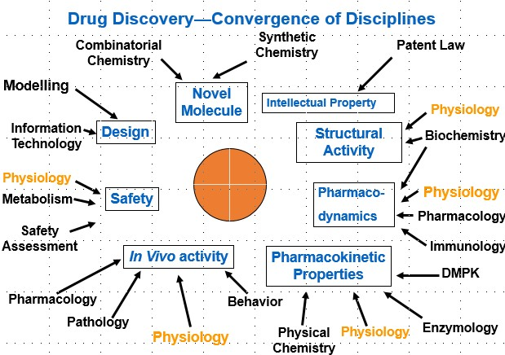

The modern day drug discovery pipeline is outlined in the next figure.  The first step is to determine an assay for the receptor.  An assay is a chemical or biological test that turns positive when a suitable binding agent interacts with the receptor.  Usually, this test is some form of colorimetric assay, in which an indicator turns a specific color when complementary ligands are present.  This assay is then used in mass screening, which is a technique whereby hundreds of thousands of compounds can be tested in a matter of days to weeks.  A pharmaceutical company will first screen their entire corporate database of known compounds.  The reason is that if a successful match is found, the database compound is usually very well characterized.  Furthermore, synthetic methods will be known for this compound, and patent protection is often present.  This enables the company to rapidly prototype a candidate ligand whose chemistry is well known and within the intellectual property of the company.

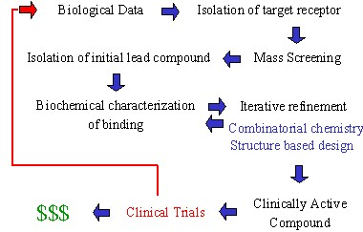

Figure 2 can be extended to figure3 for details of individual modules which are part of drug discovery process, which contains phase’s such as gene sequencing, target discovery and validation, lead discovery and then trial phases.

Ne